**Technical Documentation – Deploy_MOS**

1. Workflow – Deploys Liferay and Business Services Artifacts to an Environment.



1. Survey – User Supplied Variables

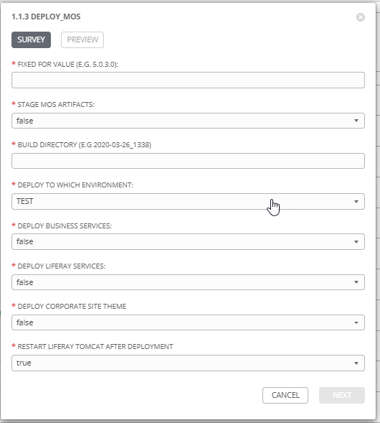

|  |  |  |  |
| --- | --- | --- | --- |
| **Survey Extra Variables** | **Prompt** | **Type** | **Description and Usage** |
| FFV | Fixed For Value | Text | The fixed for value for the deployment – must be for the format ###.###.###.### (i.e. 58.0.12.0). Numbers only with a maximum of 3 digits and there must be 4 sets separated with a ‘.’. Used to create staging and deployments directories. Used by all job templates in the workflow |
| STAGE | Stage MOS Artifacts | Multiple Choice Single Pick | True or false – Copies the Liferay and Business Artifacts from the MOS Build Releases Directory to the Staging folder. |
| ReleaseDir | Build Directory | Text | The /pencmw_common/MOS/releases/ subdirectory that contains the Liferay and Business Services artifacts |
| ENV | Deploy to Which Environment | Multiple Choice Single Pick | The Environment to Deploy to: DEV, TEST, MAINT or PROD. Only a single environment can be deployed to per workflow execution |
| APACHE | Include the Stop and Start of Apache OHS | Multiple Choice Single Pick | true or false – If true shutdown the Apache OHS on Xwebsso1bcp prior to the deployment. |
| SERVICES | Deploy Business Services | Multiple Choice Single Pick | true or false – If true deploy business services. |
| LIFERAY | Deploy Liferay Services | Multiple Choice Single Pick | true or false – if true deploy liferay services |
| CORPSITETHEME | Deploy Corporate Site Theme | Multiple Choice Single Pick | true or false – if true deploy the corporate site theme |
| RESTART_LIFERAY | Restart Liferay Tomcat After Deployment | Multiple Choice Single Pick | true or false – if true restart the Liferay Tomcat – only applies if LIFERAY or CORPSITETHEME has been set to true. |

1. Jobs Used by the workflow - http://owl.penc.local:18080/svn/deploy_automation/trunk/Ansible_PlayBooks/MOS

| **Job Template** | **Ansible Playbook** | **Project** | **Description and Usage** |
| --- | --- | --- | --- |
| create_mos_variables | create_mos_vars_ansible.yml | MOS/MEX Deployments | DeploymentLogDir: /codemove_common/dp_automation/deployments/005.000/005.000.003.000/MOS  SiteBacker_Serial: QNJPDGLZACBDBXBWJPYSBQZWZAWUIENV  StageDir: /codemove_common/dp_automation/stage/005.000/005.000.003.000/MOS  apache_host: none  date_time: '20200629_1326'  liferay_deployment_host: 'dliferay71bcp,dliferay72bcp'  liferay_port: 4443  services_deployment_host: 'dbusserv1bcp,dbusserv2bcp'  stage_server: diagoras1bcp |
| stage_files_mos_ansible | stage_files_mos_ansible.yml | MOS/MEX Deployments | Copies MOS Services Artifacts from /pencmw_common/MOS/releases/{{ReleaseDir}} to the {{StageDir}}/{{ReleaseDir}}  The job fails if the /pencmw_common/MOS/releases/{{ReleaseDir}} build directory does not exist.  If the stage_server is set to ‘none’ as opposed to diagoras1bcp, the playbook does not actually do anything, all of the tasks are skipped.  The last task of the job creates a Staging Report in the {{DeploymentLogDir}} in html format.  Note: that this Job Template is used by the Incremental Business Services Deployment, WES Deployment and MSC Deployment workflows. |
| proceed | Approval Step | N/A | An approval step is required after the staging of the Artifacts. This allows the Release Team to review the staging report in /codemove_common/dp_automation/deployments/005.000/005.000.003.000/MOS prior to carrying out the actual deployment. |
| apache_stop_ansible | apache_stop_ansible.yml | MOS/MEX Deployments | If {{APACHE}} is set to true: Stops the Apache OHS listener for the {{ENV}} environment on the appropriate websso1bcp server prior to deployment in order to lock out users. If {{APACHE}} is set to false it does nothing. |
| deploy_services_ansible | deploy_services_ansible.yml  Calls  deploy_single_service_ansible.yml | MOS/MEX Deployments | If {{SERVICES}} is set to true, stops all of the Business Services and deploys any business services to {{ENV}} that have been staged, then starts all of the Business Services.  The playbook operates in serial mode so it deploys to a single server at a time (i.e. no outage in a load balanced environment) |
| deploy_liferay_ansible | deploy_liferay_ansible.yml | MOS/MEX Deployments | If {{LIFERAY}} is set to true deploys any Liferay Artificats that have been staged to {{ENV}}.  If {{CORPSITETHEME}} is set to true deploys the Corporate Site Theme that has been staged.  If {{RESTART_LIFERAY}} is true and one of {{LIFERAY}} or {{CORPSITETHEME}} is true the tomcat application server is restarted.  After deployment and the tomcat services are available it checks for presence of the {{SiteBacker_Serial}} string in the html output when the Liferay host URL is accessed.  The playbook operates in serial mode so it deploys to a single server at a time (i.e. no outage in a load balanced environment) |
| apache_start_ansible | apache_start_ansible.yml | MOS/MEX Deployments | If {{APACHE}} is set to true: Starts the Apache OHS listener for {{ENV}} environments on the appropriate websso1bcp server after deployment. If {{APACHE}} is set to false it does nothing. |
| deployment_complete_mos_ansible | deployment_complete_mos_ansible.yml | MOS/MEX Deployments | Populates an html formatted deployment log {{DeploymentLogDir}}/{{ReleaseDir}}/{{ENV}}_MOS_{{date_time}}.html |
| liferay_health_check_ansible | liferay_health_check_ansible.yml | MOS/MEX Deployments | Executes the Python Liferay Health Check of the {{ENV}} environment and emails the result to the Release Team. If {{ENV}} is PROD it does nothing as the health check is not available for Productions. |